Module 1
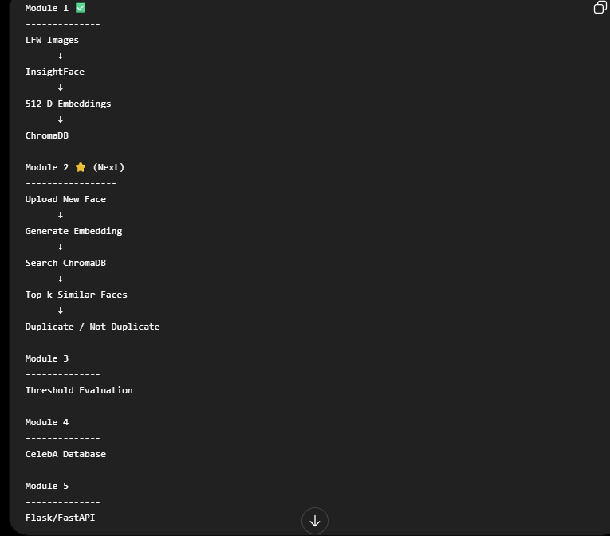

What am I suppose to de with these many of datasets?

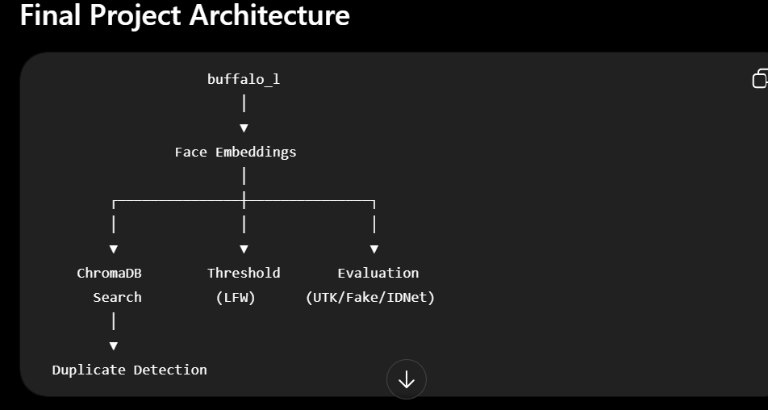
MODULE1 ARCHITECTURE :
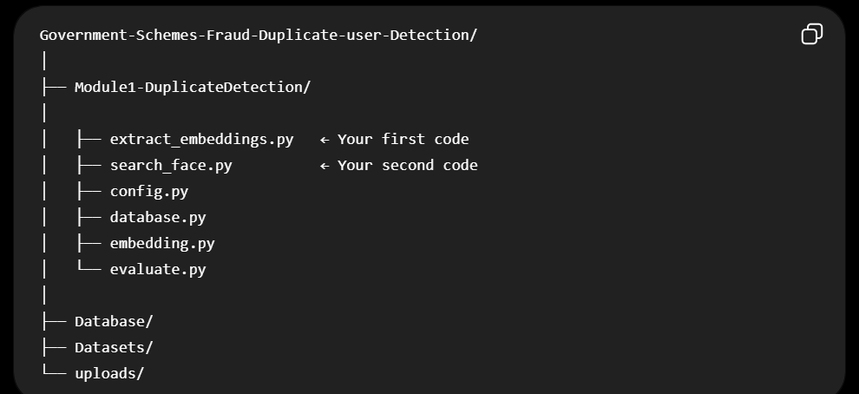

Working
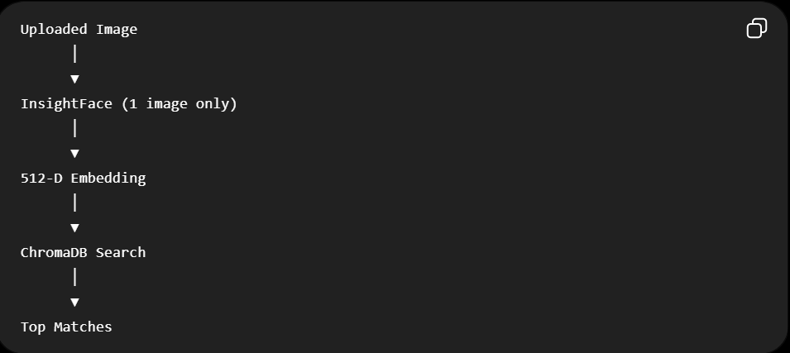

Yes. Using only LFW + UTKFace is a good choice for a B.Tech/college major project. In fact, I'd recommend it over trying to process every available dataset on a CPU.
Why this combination works
✅ LFW (Labeled Faces in the Wild)
- Standard benchmark for face recognition and verification.
- Multiple images per identity.
- Perfect for testing duplicate detection.
- Around 13,000 images, so it's manageable.
✅ UTKFace
- Around 20,000 face images.
- Includes diverse ages, genders, and ethnicities.
- Good for demonstrating that your system has been evaluated on a more diverse dataset.
- Still manageable on a CPU.
Together, you'll have roughly:
LFW ≈ 13,000 images
UTKFace ≈ 20,000 images
-------------------------
Total ≈ 33,000 images
A database of 33,000+ face embeddings is already substantial for a student project.

Is this enough for a Government Scheme Fraud Detection project?
Yes, because the datasets are only for development and evaluation.
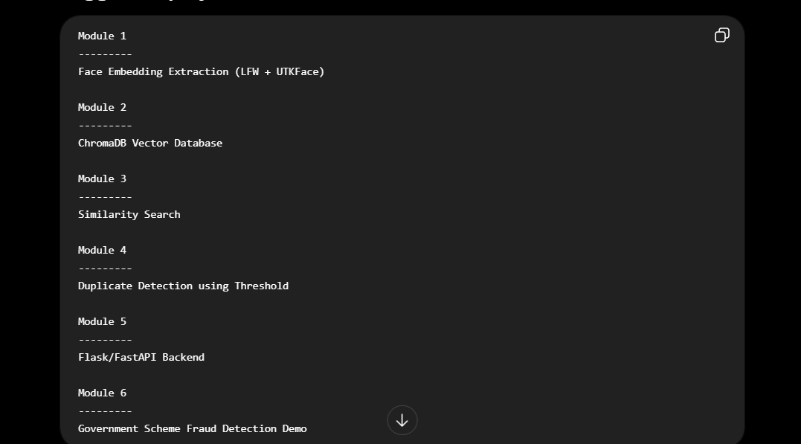

What you can write in your report
Datasets Used
- LFW: Used to validate face recognition and duplicate matching because it contains multiple images of the same identities.
- UTKFace: Used to evaluate the system on a more demographically diverse set of faces and to increase the size of the searchable face database.
This is a reasonable and defensible design choice.

Should you include CelebA?
Not necessarily.
CelebA is useful if you specifically want:
- A much larger database (200k+ images).
- Scalability experiments.
But for your current project:
- It will take much longer to process on a CPU.
- It doesn't fundamentally change your system architecture.

My recommendation
Stick with:
- ✅ LFW
- ✅ UTKFace
Then invest your time in making the rest of the project strong:
- A clean Flask/FastAPI backend.
- A good duplicate detection interface.
- Proper threshold evaluation (ROC curve, Precision, Recall, F1-score).
- A simple dashboard showing the uploaded image, top matches, similarity scores, and duplicate decision.
A polished end-to-end system with these two datasets is more valuable than an unfinished system that attempts to use five different datasets.

